PIZZA EXPRESS

[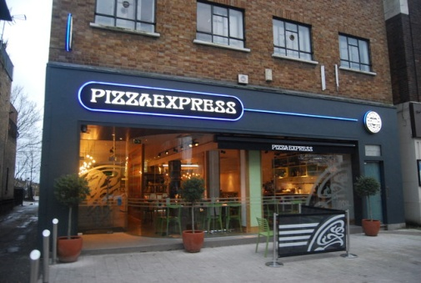](https://www.geograph.org.uk/photo/3910479)

Pizza express is a baked pizza restaurant. There are many pizza restaurants all over London. Their menu is very varied with pizzas of all tastes. According to the assessment of the people, it is a fast restaurant, delicious and it offers a good service

Mauricio and Fernando